Bahria University

Karachi Campus

**COURSE: CSC-320 OPERATING SYSTEM**

**TERM: Spring 2020, CLASS: BSE- 4B**

PROJECT REPORT

**SUBMITTED BY:**

Name of group members and registration number:

1. Aqib Mehmood 57231

2. M Arbab Anjum 57226

3. Syed Ali Abbas 57285

**SUBMITTED TO:**

Engr. Osama Rehman/ Engr. Fareeha Dilawar

**SIGNED REMARKS: SCORE:**

Table of Contents

BACKGROUND: 3

INTRODUCTION: 3

PROJECT PARADIGM 4

MECHANISM AND WORKING: 5

FUNCTIONALITIES: 25

REMAINING CODE MODULES, API’S AND PLATFORMS: 25

FUTURE WORK: 25

CONCLUSION: 26

REFERENCES: 26

# BACKGROUND:

File management is one of the basic and important features of operating system. Operating system is used to manage files of computer system. All the files with different extensions are managed by operating system.

A file is collection of specific information stored in the memory of computer system. File management is defined as the process of manipulating files in computer system, it management includes the process of creating, modifying and deleting the files.

Our files have several common characteristics built in. Each file is made up of data, but also metadata is embedded into the file to help the operating system (OS) manage how the file works and how it is stored. Metadata records file information such as the author, file creation date, modified date, and file size.

File management is a process of maintaining any kind of records in a proper manner like your work document or your money records this is the process to divide things in different stages and in writing from so that in future when needed it will be easy to get that particular record.

In the 20th century, vertical filing cabinets were introduced to store a different kind of files. Then the computer was used to store a different kind of file in the system with the help of the LAN/wan network. Then portable flash drive was introduced to store files and to transfer data from one system to another. Then cloud storage was introduced this cloud storage made easy to store files from anywhere and from any computer this prevent the user from losing the data or from any data threat with their high-security methods.

# INTRODUCTION:

Computer users spend time every day interacting with digital files and folders, including creating, downloading, naming, moving, saving, copying, reviewing, navigating, searching for, sharing, and deleting them. This activity, called *file management*(FM).

File management is an art of storing, naming, sorting and handling documents files in a systematic manner. So that in future it will easy to retrieve data.

A ***file management system*** is a type of software that manages data files in a computer system. It has limited capabilities and is designed to manage individual or group files, such as special office documents and records.

The following are some of the tasks performed by file management of operating system of any computer system:

1. It helps to create new files in computer system and placing them at the specific locations.
2. It helps in easily and quickly locating these files in computer system.
3. It helps to stores the files in separate folders known as directories. These directories help users to search file quickly or to manage the files according to their types or uses.
4. It helps the user to modify the data of files or to modify the name of the file in the directories etc.

  File management helps users to organize their valuable documents in a systematic manner for better and efficient use of it.

# PROJECT PARADIGM

The file is actually the collection of associated information. This file-system prearranged into

directory for efficient usage. Every directory has a number of files and other directories. The directory is defined as a

bit which distinguish the entries that explained file and subdirectories in the recent directory. By theoretically we

may change the file into a directory by changing its bit. A file system is considered as an element of an operating-

system that manage the storage space and operation of files on media like disks.

The file is actually the collection of associated information. This file-system prearranged into

directory for efficient usage. Every directory has a number of files and other directories. The directory is defined as a

bit which distinguish the entries that explained file and subdirectories in the recent directory. By theoretically we

may change the file into a directory by changing its bit. A file system is considered as an element of an operating-

system that manage the storage space and operation of files on media like disks.

The file is actually the collection of associated information. This file-system prearranged into

directory for efficient usage. Every directory has a number of files and other directories. The directory is defined as a

bit which distinguish the entries that explained file and subdirectories in the recent directory. By theoretically we

may change the file into a directory by changing its bit. A file system is considered as an element of an operating-

system that manage the storage space and operation of files on media like disks.

The file is actually the collection of associated information. This file-system prearranged into

directory for efficient usage. Every directory has a number of files and other directories. The directory is defined as a

bit which distinguish the entries that explained file and subdirectories in the recent directory. By theoretically we

may change the file into a directory by changing its bit. A file system is considered as an element of an operating-

system that manage the storage space and operation of files on media like disks.

The file is actually the collection of associated information. This file-system prearranged into

directory for efficient usage. Every directory has a number of files and other directories. The directory is defined as a

bit which distinguish the entries that explained file and subdirectories in the recent directory. By theoretically we

may change the file into a directory by changing its bit. A file system is considered as an element of an operating-

system that manage the storage space and operation of files on media like disks.

VIII. CONCLUSION

This paper gives a view on file system in an operating system. The file system, simple file system, distributed file

system, UNIX file system and LINUX file system are discussed in detail that give a sound knowledge about the file-

system in OS. The file is actually the collection of associated information. This file-system prearranged into

directory for efficient usage. Every directory has a number of files and other directories. The directory is defined as a

bit which distinguish the entries that explained file and subdirectories in the recent directory. By theoretically we

may change the file into a directory by changing its bit. A file system is considered as an element of an operating-

system that manage the storage space and operation of files on media like disks. This review paper also provides a

brief view about operating system. An operating system (OS) is a program that works like an interface to manage

the software and hardware. Every computer system has an operating system to run the other program such as

application programs. The most famous file system in the world of PC Is FAT family that is discussed in this paper.

VIII. CONCLUSION

This paper gives a view on file system in an operating system. The file system, simple file system, distributed file

system, UNIX file system and LINUX file system are discussed in detail that give a sound knowledge about the file-

system in OS. The file is actually the collection of associated information. This file-system prearranged into

directory for efficient usage. Every directory has a number of files and other directories. The directory is defined as a

bit which distinguish the entries that explained file and subdirectories in the recent directory. By theoretically we

may change the file into a directory by changing its bit. A file system is considered as an element of an operating-

system that manage the storage space and operation of files on media like disks. This review paper also provides a

brief view about operating system. An operating system (OS) is a program that works like an interface to manage

the software and hardware. Every computer system has an operating system to run the other program such as

application programs. The most famous file system in the world of PC Is FAT family that is discussed in this paper.

The file is actually the collection of associated information. This file-system prearranged into directory for efficient usage. Every directory has a number of files and other directories. The directory is defined as a bit which distinguish the entries that explained file and subdirectories in the recent directory. By theoretically we may change the file into a directory by changing its bit. A file system is considered as an element of an operating system that manage the storage space and operation of files on media like disks.

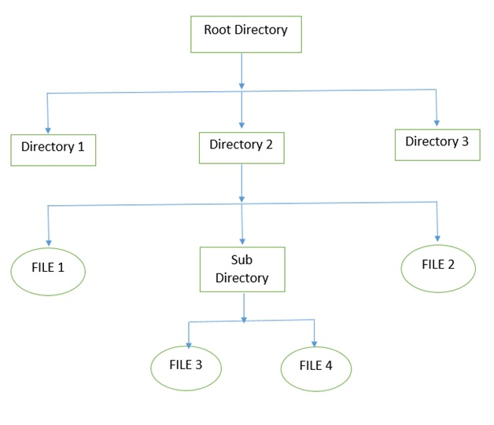

The above figure shows the general hierarchy of the storage in an operating system. In this figure the root directory is present at the highest level in the hierarchical structure. It includes all the subdirectories in which the files are stored. Subdirectory is a directory present inside another directory in the file storage system. The directory base storage system ensures better organization of files in the memory of the computer system.

# MECHANISM AND WORKING:

**Menu Code:**

#include <stdio.h>

int main(void) {

printf("=========================================================================\n");

printf("-----------------------File Management Project---------------------------\n");

printf("=========================================================================\n");

printf("Welcome, The Main Menu is given below:\n");

printf("1- List all Files and Directories\n");

printf("2- Create New Files\n");

printf("3- Delete Existing Files\n");

printf("4- Rename Files\n");

printf("5- Edit File Content\n");

printf("6- Search Files\n");

printf("7- Details of Particular File\n");

printf("8- View Content of File\n");

printf("9- Sort File Content\n");

printf("10- List only Directories(Folders)\n");

printf("11- List Files of Particular Extension\n");

printf("12- Count Number of Directories\n");

printf("13- Count Number of Files\n");

printf("14- Sort Files in a Directory\n");

printf("0- Exit\n");

printf("\nWhat action you want to Perform?\nEnter 1-14\n");;

return 0;

}

**Main Code:**

#!/bin/bash

i="0"

while [ $i -lt 100 ]

do

gcc project.c -o proj

./proj

read opt1

if [ $opt1 == 1 ]

then

echo "List all files and Directories here.."

echo "Showing all files and directories...."

sleep 3

echo "Loading.."

sleep 3

echo "-------------------------------OutPut------------------------------------"

ls

echo " "

elif [ $opt1 == 2 ]

then

echo "Create New Files here.."

echo "Which type of file you want to create !"

echo "1- .c"

echo "2- .sh" echo "3- .txt" echo "Enter your choice from 1-3" read filechoice

if [ $filechoice == 1 ]

then

echo "Enter File Name without .c Extension"

read filename

touch $filename.c

echo "-------------------------------OutPut------------------------------------"

echo "File Created Successfully"

echo " "

elif [ $filechoice == 2 ]

then

echo "Enter File Name without .sh Extension"

read filename2

touch $filename2.sh

echo "-------------------------------OutPut------------------------------------"

echo "File Created Successfully"

echo " "

elif [ $filechoice == 3 ]

then

echo "Enter File Name without .txt Extension"

read filename3

touch $filename3.txt

echo "-------------------------------OutPut------------------------------------"

echo "File Created Successfully"

echo " "

else

echo "Inavlid Input..Try Again."

echo " "

fi

elif [ $opt1 == 3 ]

then

echo "Delete existing files here.. "

echo "Enter name of File you want to Delete!"

echo "Note: Please Enter full Name with Extension."

read delfile

echo "-------------------------------OutPut------------------------------------"

if [ -f "$delfile" ];

then

if [ -f "$delfile" ];

then

rm $delfile

echo "Successfully Deleted." echo " "

else echo "File Does not Exist..Try again" echo " " fi

elif [ $opt1 == 4 ]

then

echo "-------------------------------OutPut------------------------------------"

echo "Rename files here.."

echo "Enter Old Name of File with Extension.."

read old

echo "Checking for file..."

sleep 3

if [ -f "$old" ];

then

echo "Ok File Exist."

echo "Now Enter New Name for file with Extension"

read new

mv $old $new

echo "Successfully Rename."

echo "Now Your File Exist with $new Name"

else

echo "$old does not exist..Try again with correct filename."

fi

echo " "

elif [ $opt1 == 5 ]

then

echo "Edit file content here.."

echo "Enter File Name with Extension : "

read edit

echo "-------------------------------OutPut------------------------------------"

echo "Checking for file.."

sleep 3

if [ -f "$edit" ];

then

echo "Opening file.."

sleep 3

nano $edit

echo " "

else

echo "$edit File does not exist..Try again."

fi

elif [ $opt1 == 6 ]

then echo "Search files here.." echo "Enter File Name with Extension to search" read f

echo "-------------------------------OutPut------------------------------------"

if [ -f "$f" ];

then

echo "Searching for $f File"

echo "File Found."

find /home -name $f

echo " "

else

echo "File Does not Exist..Try again."

echo " "

fi

elif [ $opt1 == 7 ]

then

then

echo "Detail of file here.."

echo "Enter File Name with Extension to see Detail : "

read detail

echo "-------------------------------OutPut------------------------------------"

echo "Checking for file.."

sleep 4

if [ -f "$detail" ];

then

echo "Loading Properties.."

stat $detail

else

echo "$detail File does not exist..Try again"

fi

echo " "

elif [ $opt1 == 8 ]

then

echo "View content of file here.."

echo "Enter File Name : "

read readfile

echo "-------------------------------OutPut------------------------------------"

if [ -f "$readfile" ];

then echo "Showing file content.."

sleep 3

cat $readfile else

echo "$readfile does not exist" fi echo " "

elif [ $opt1 == 9 ]

then

echo "Sort files content here.."

echo "Enter File Name with Extension to sort :"

read sortfile

echo "-------------------------------OutPut------------------------------------"

if [ -f "$sortfile" ];

then

echo "Sorting File Content.."

sleep 3

sort $sortfile

else

echo "$sortfile File does not exist..Try again."

fi

echo " "

elif [ $opt1 == 10 ]

then

echo "-------------------------------OutPut------------------------------------"

echo "List of all Directories here.."

echo "showing all Directories..."

echo "Loading.."

sleep 3

ls -d */

echo " "

elif [ $opt1 == 11 ]

then

echo "List of Files with Particular extensions here.."

echo "Which type of file list you want to see?"

echo "1- .c"

echo "2- .sh"

echo "3- .txt"

echo "Enter your choice from 1-3"

read extopt

echo "-------------------------------OutPut------------------------------------" if [ $extopt == 1 ]

then

echo "List of .c Files shown below." echo "Loading.."

sleep 3 ls *.c elif [ $extopt == 2 ]

then

echo "List of .sh Files shown below."

echo "Loading.."

sleep 3

ls *.sh

elif [ $extopt == 3 ]

then

echo "List of .txt Files shown below."

echo "Loading.."

sleep 3

ls *.txt

else

echo "Invalid Input..Try again.." fi

echo " "

elif [ $opt1 == 12 ]

then

echo "-------------------------------OutPut------------------------------------"

echo "Total number of Directories here.."

echo "Loading all directories.."

sleep 3

echo "Counting.."

sleep 3

echo "Number of Directories are : "

echo */ | wc -w

echo " "

elif [ $opt1 == 13 ]

then

echo "-------------------------------OutPut------------------------------------"

echo "Total Numbers of Files in Current Directory here.."

echo "Loading all files.."

sleep 3

echo "Number of Files are : "

ls -l | grep -v 'total' | grep -v '^d' | wc -l

echo " "

elif [ $opt1 == 14 ]

then echo "-------------------------------OutPut------------------------------------"

echo "Sort Files here.." echo "Your Request of Sorting file is Generated." echo "Sorting.." sleep 3

ls | sort

echo " "

elif [ $opt1 == 0 ]

then

echo "Good Bye.."

echo "Successfully Exit"

break

else

echo "Invalid Input..Try again...."

fi

i=$[$i+1]

done

**Output Screenshots:**

**Main Menu:**

Main menu of Project that display all the available option to the users. The users need to choose one out of 14 and the particular command will be executed according to the user input.

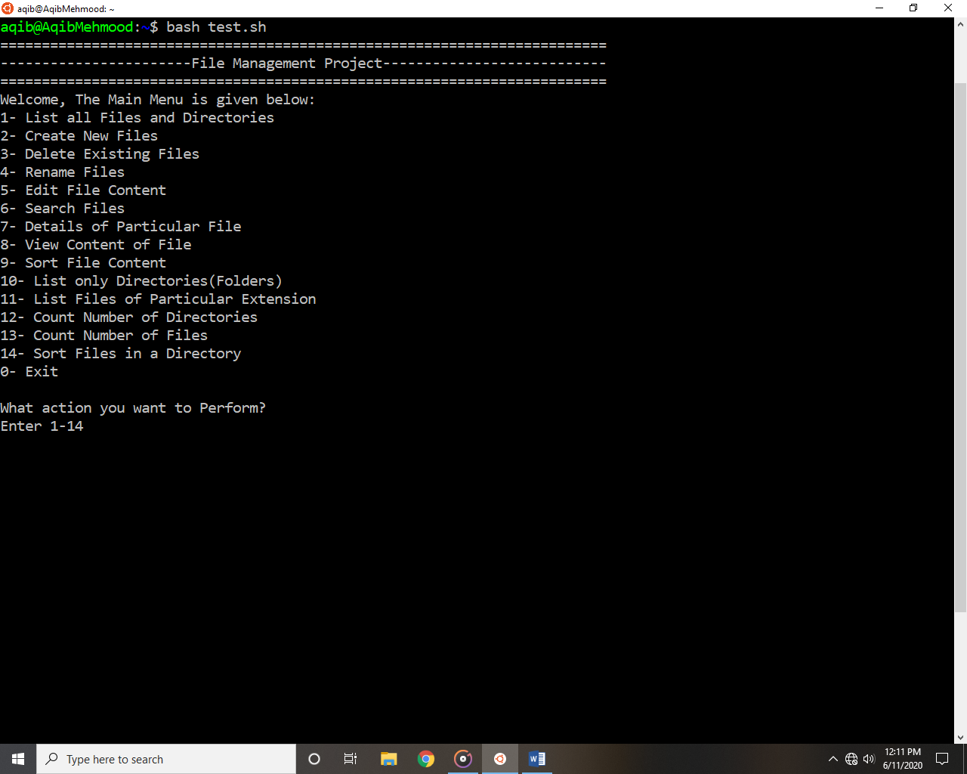

**Choice 01 Output:**

If user enter 1 then the List of all Files and Directories will be displayed.

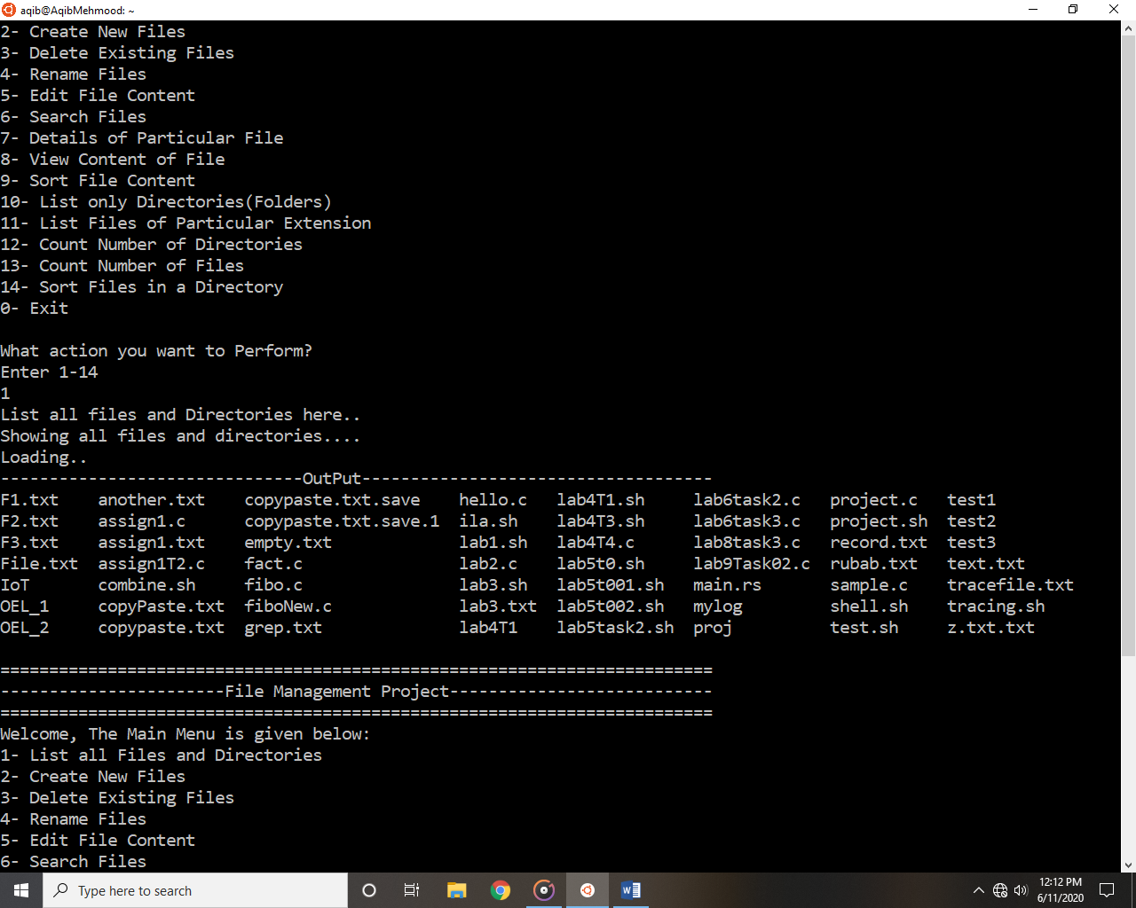

**Choice 02 Output:**

If user wants to create new file then he needs to enter 2.

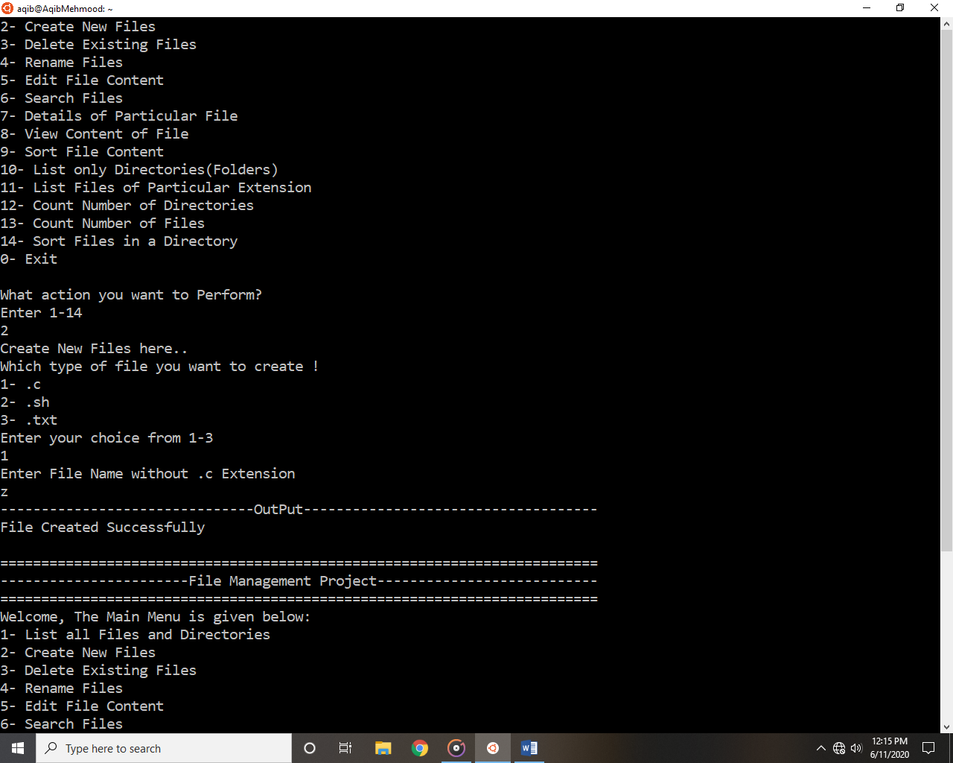

**Choice 03 Output:**

If user wants to delete existing file then he needs to enter 3.

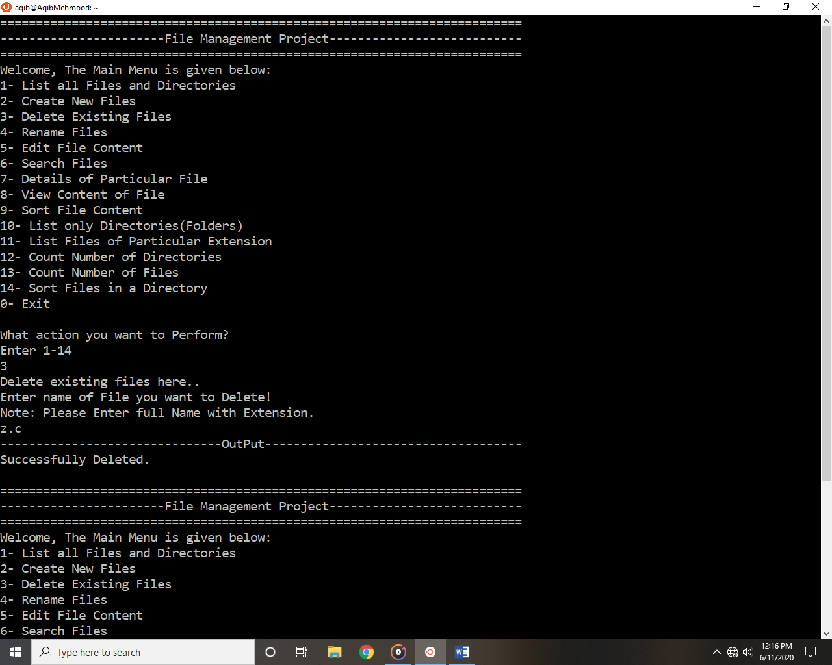

**Choice 04 Output:**

If user wants to rename an existing file then he needs to enter 4.

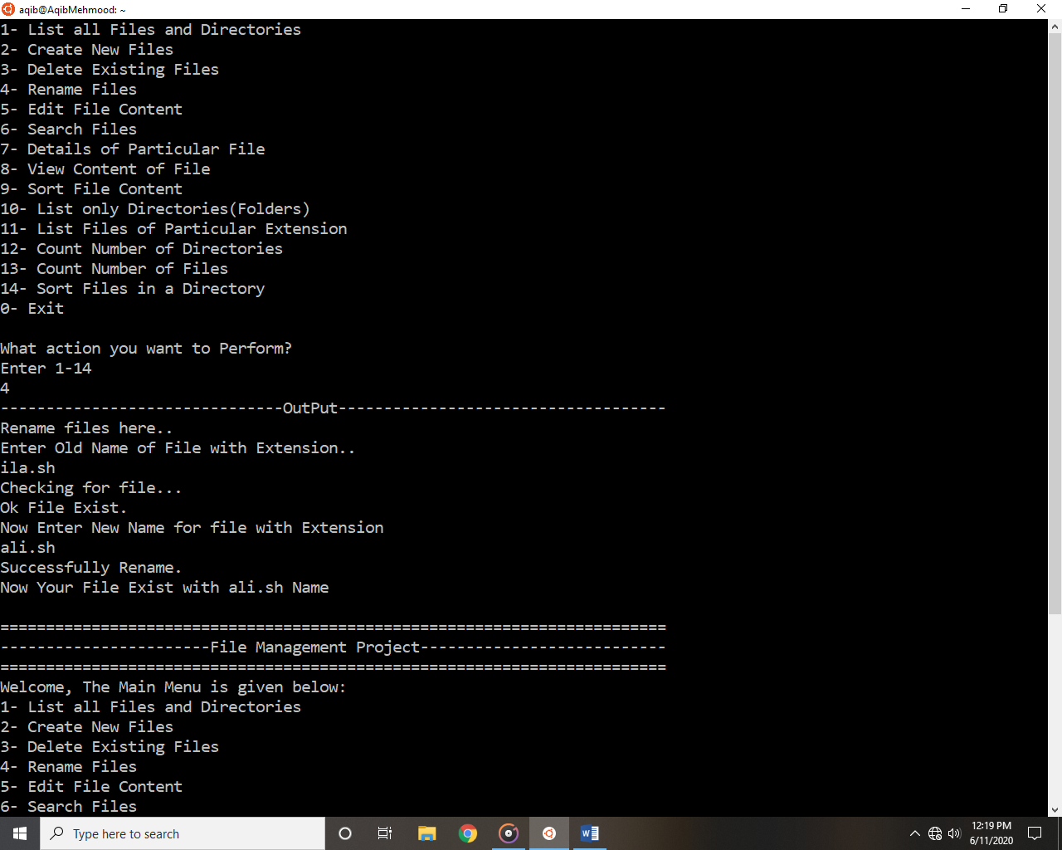

**Choice 05 Output:**

If user wants to edit file content then he needs to enter 5.

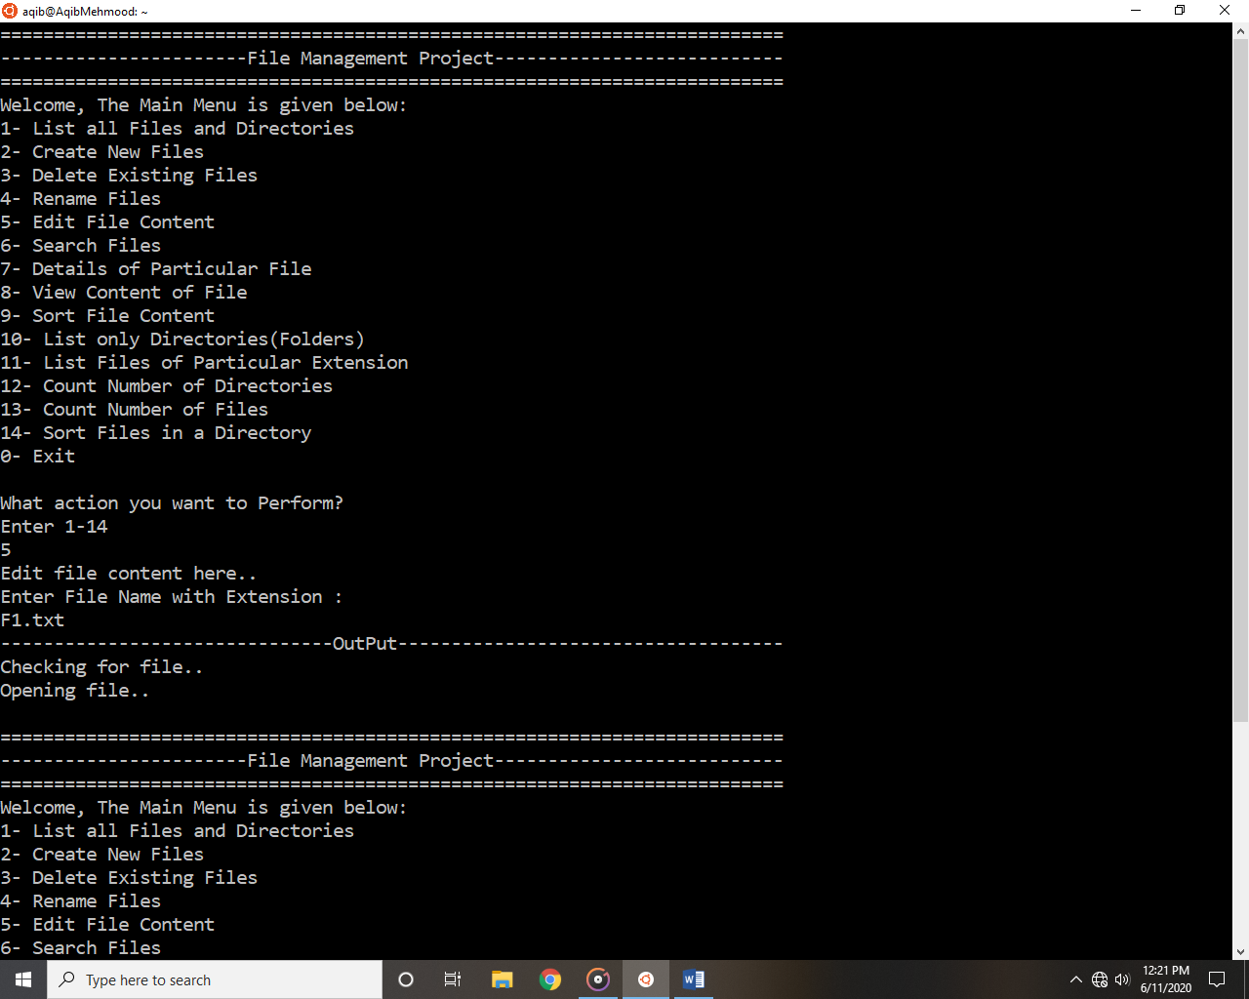

**Choice 06 Output:**

If user wants to search for a file then he needs to enter 6.

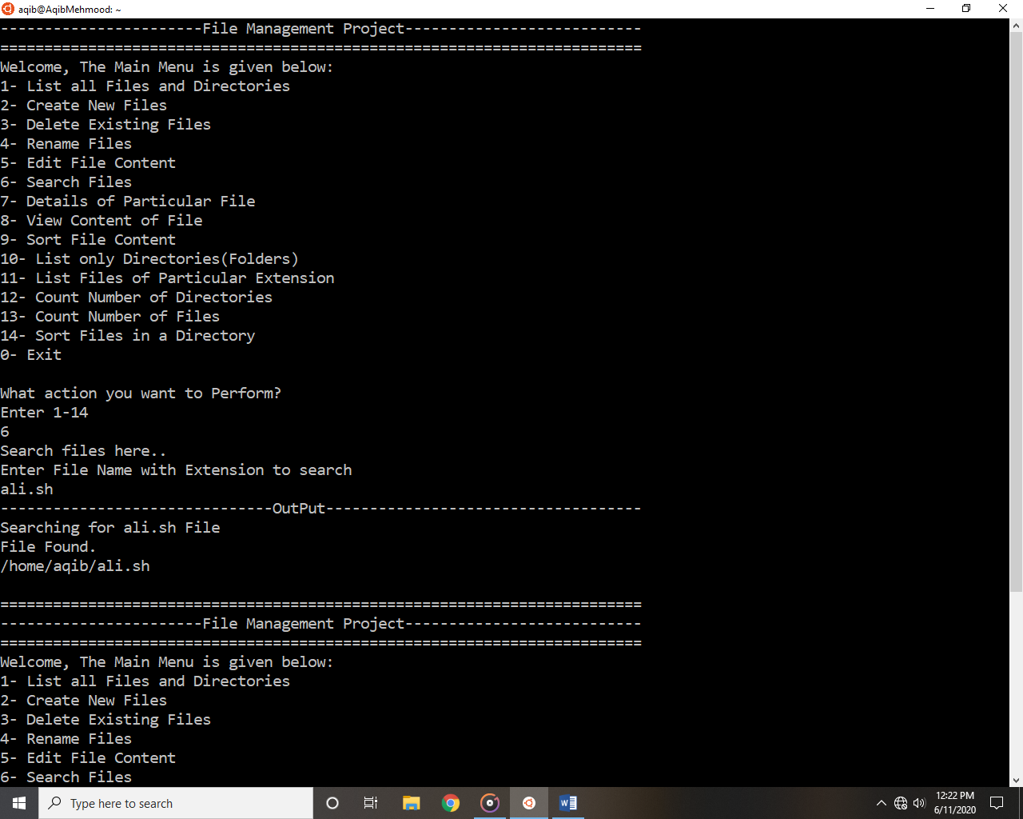

**Choice 07 Output:**

If user wants to see the details of file then he needs to enter 7.

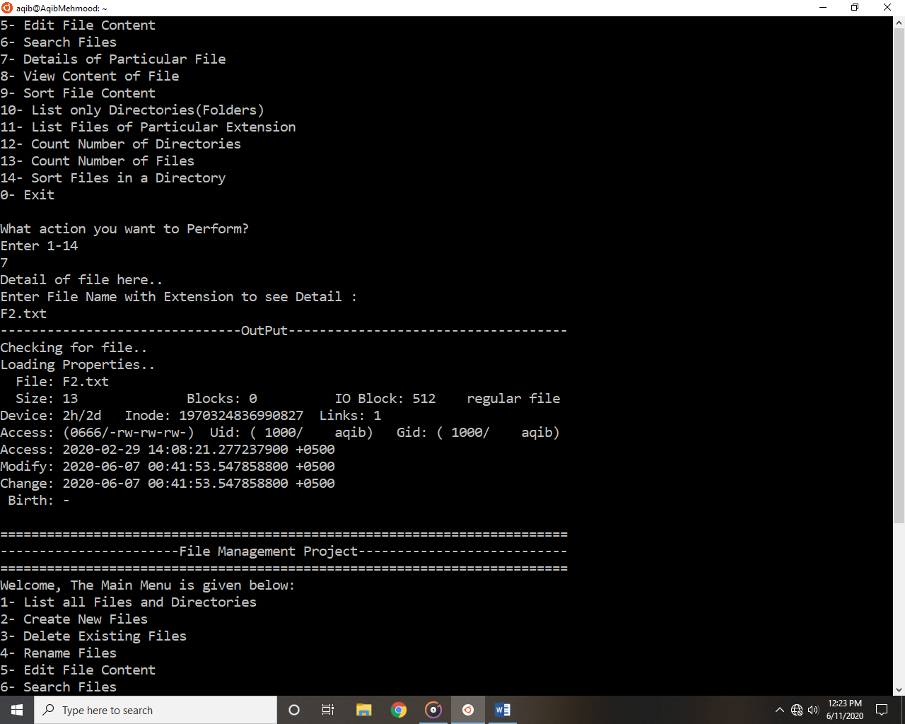

**Choice 08 Output:**

If user wants to view content of file then he needs to enter 8.

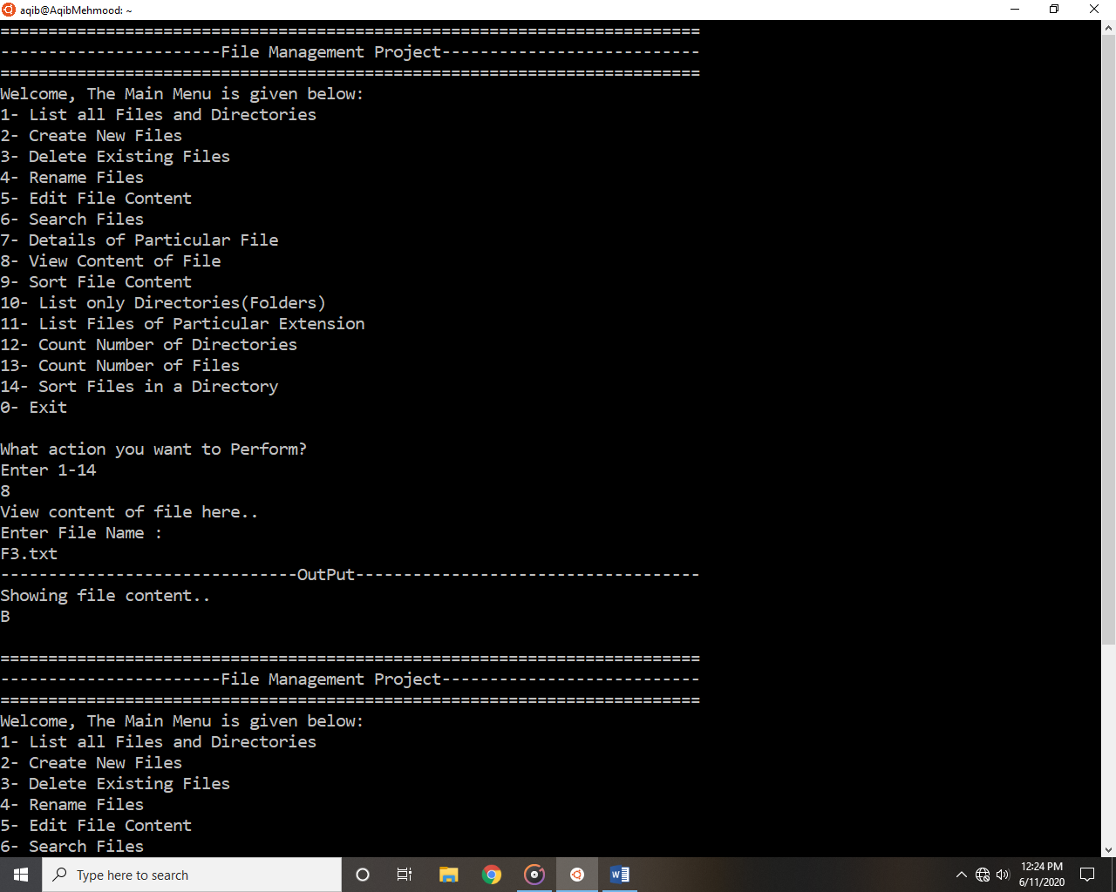

**Choice 09 Output:**

If user wants to sort the file content then he needs to enter 9.

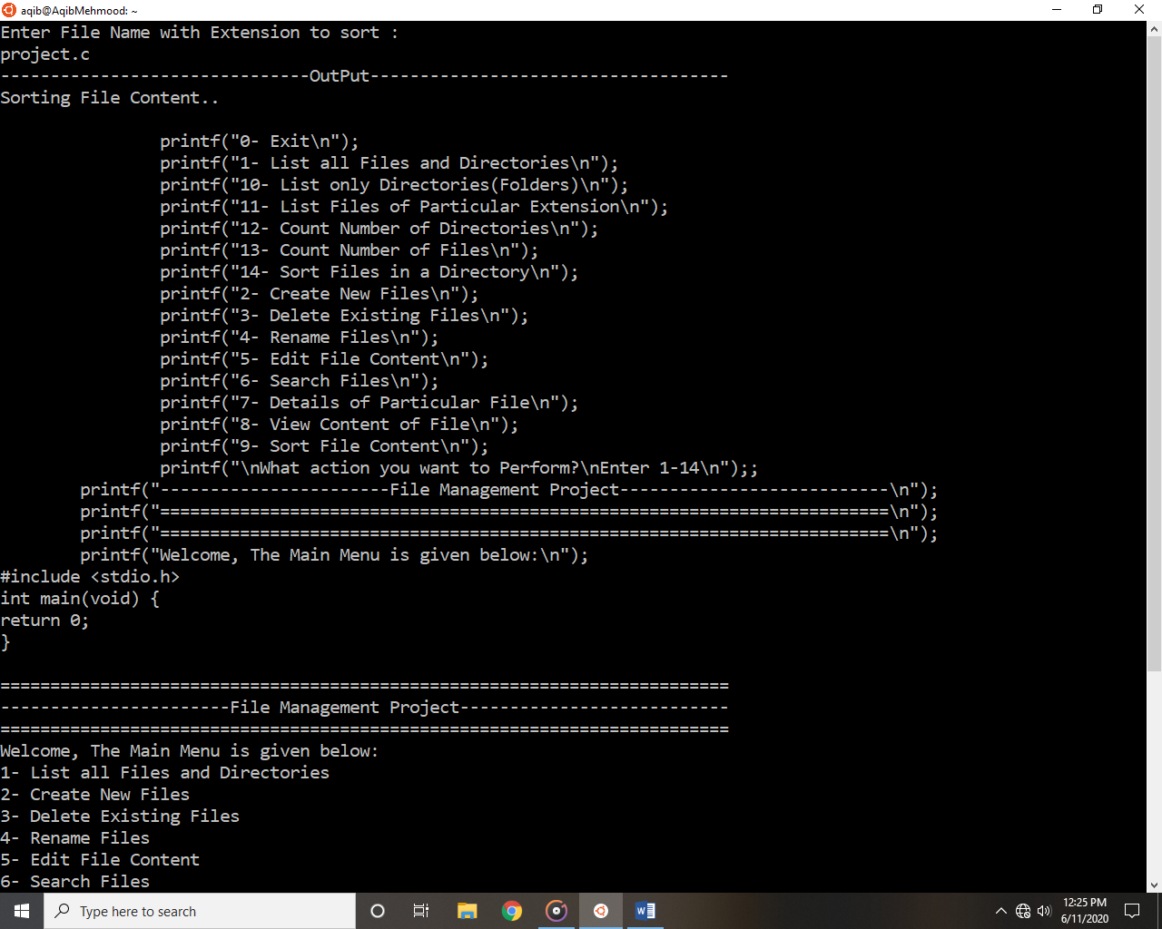

**Choice 10 Output:**

If user wants to list all directories then he needs to enter 10.

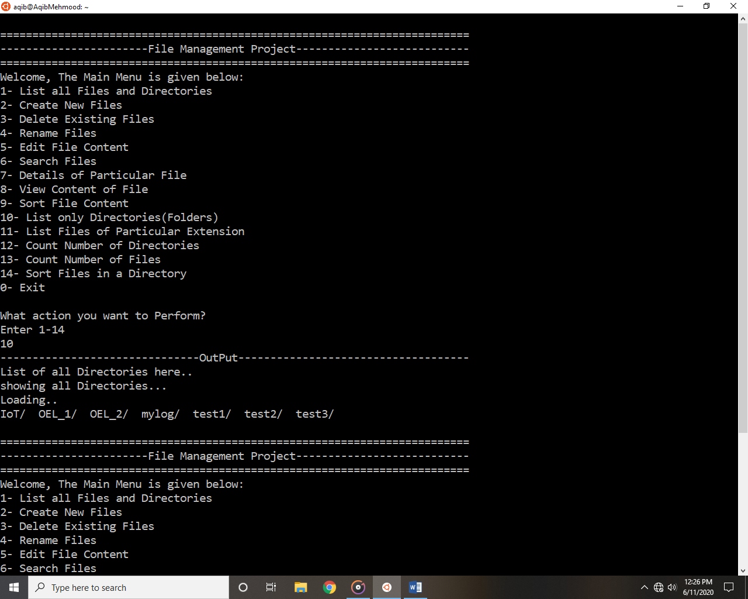

**Choice 11 Output:**

If user wants to list all files with the same extension then he needs to enter 11.

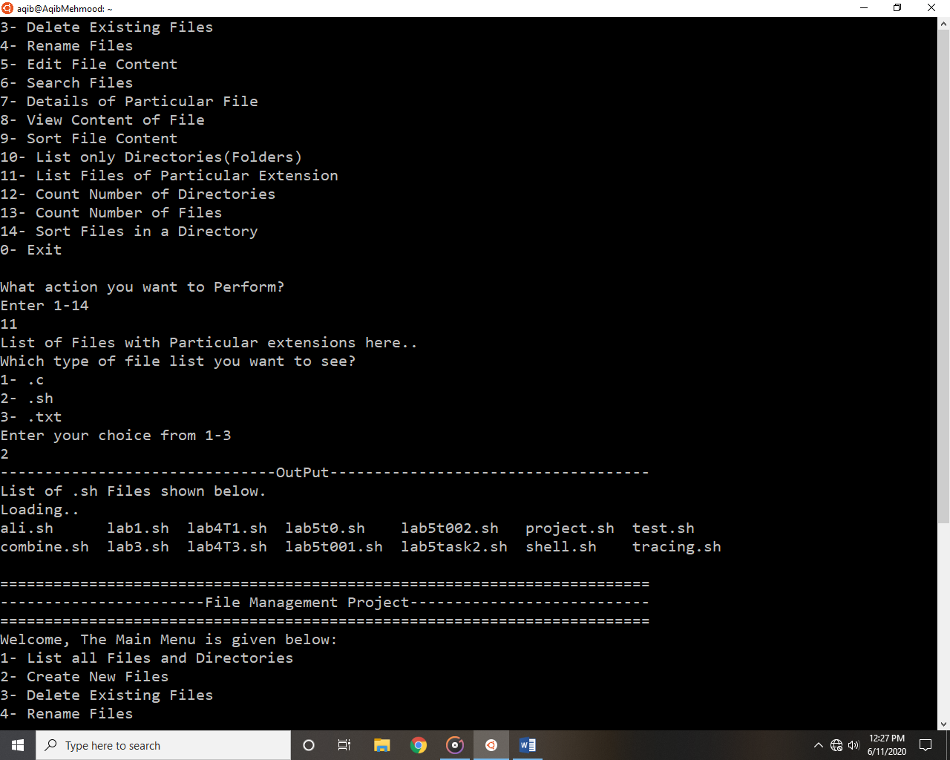

**Choice 12 Output:**

If user wants to number of directories then he needs to enter 12.

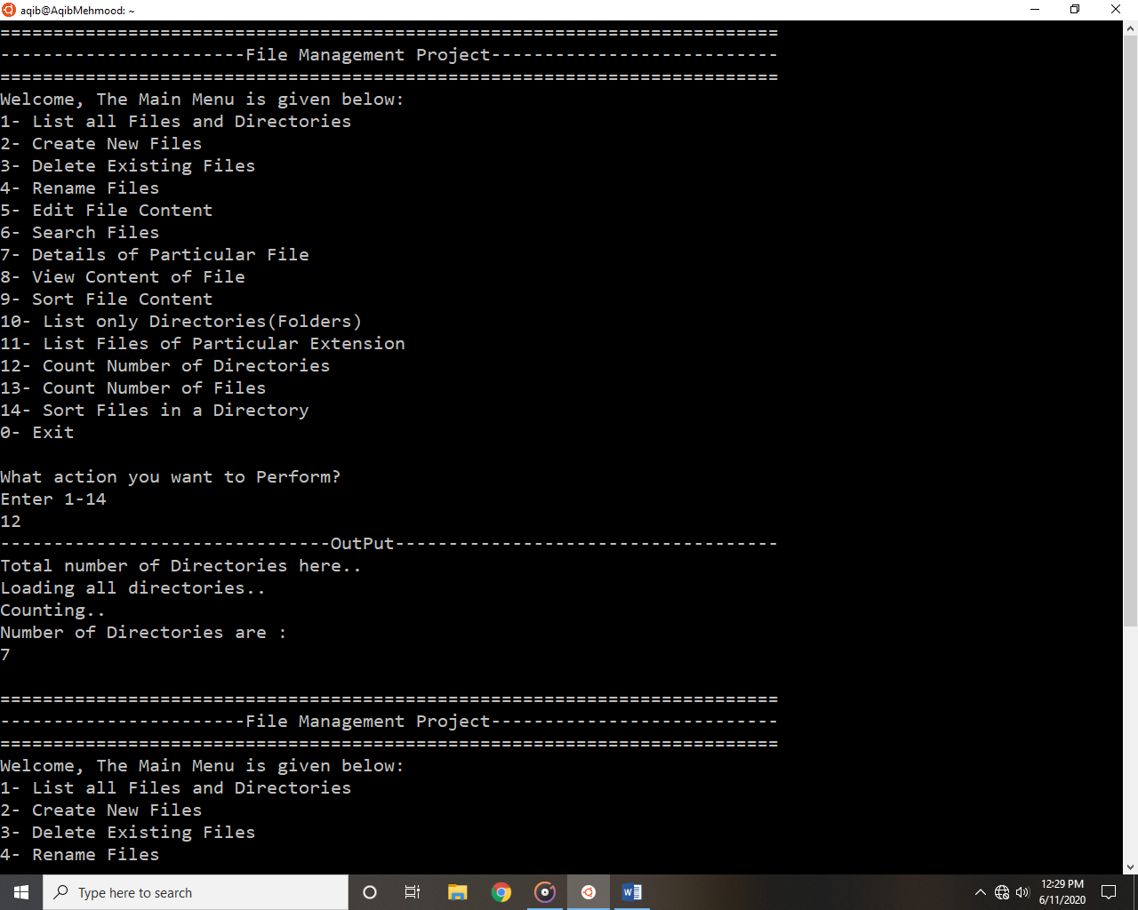

**Choice 13 Output:**

If user wants to count number of files then he needs to enter 13.

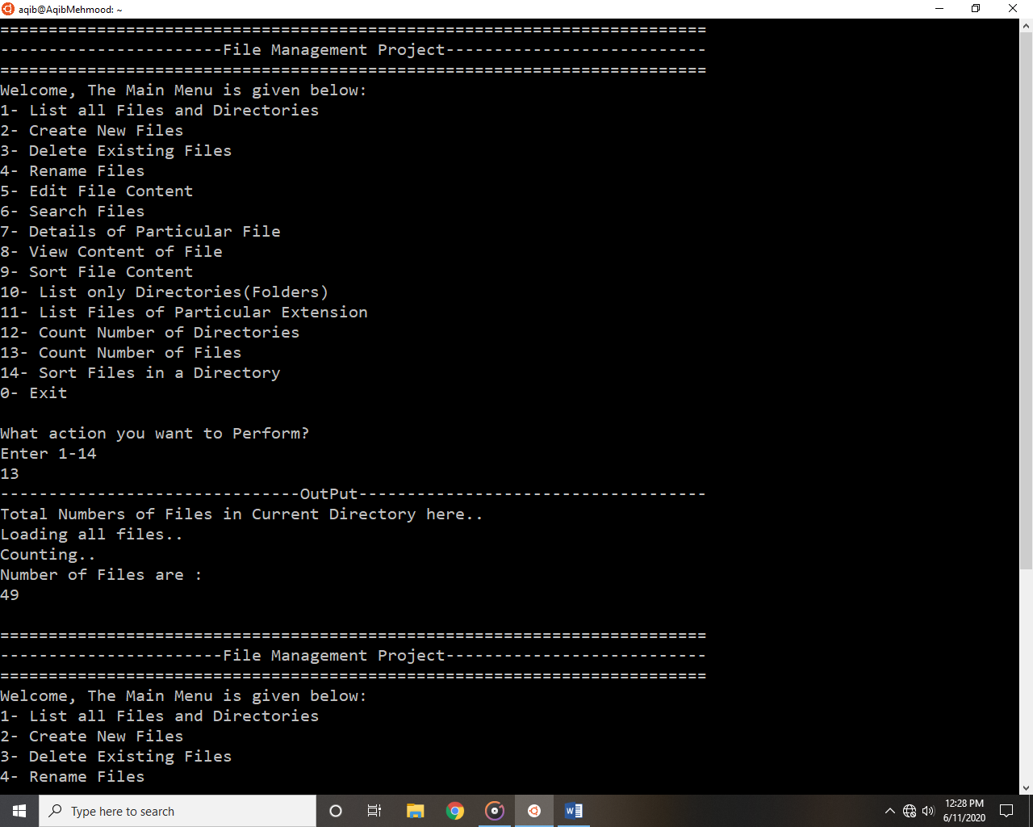

**Choice 14 Output:**

If user wants to sort all files in a directories then he needs to enter 14.

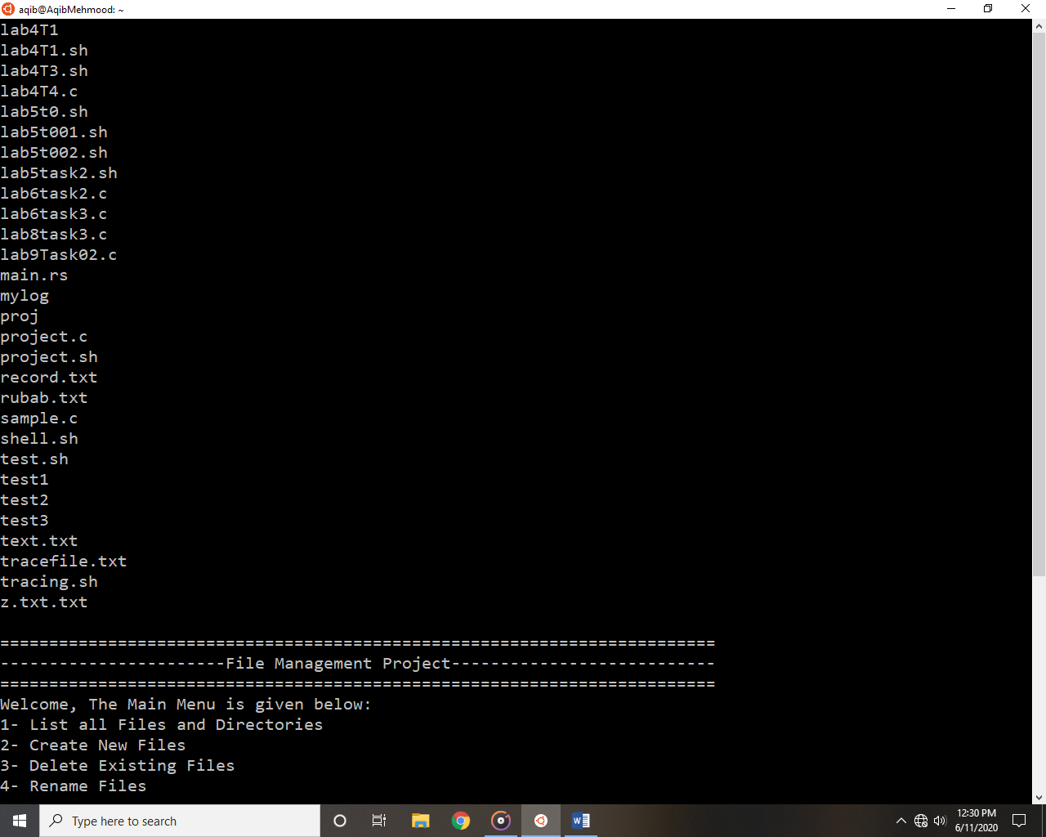

**Exit option:**

If user wants to exit from Management system then he needs to enter 0.

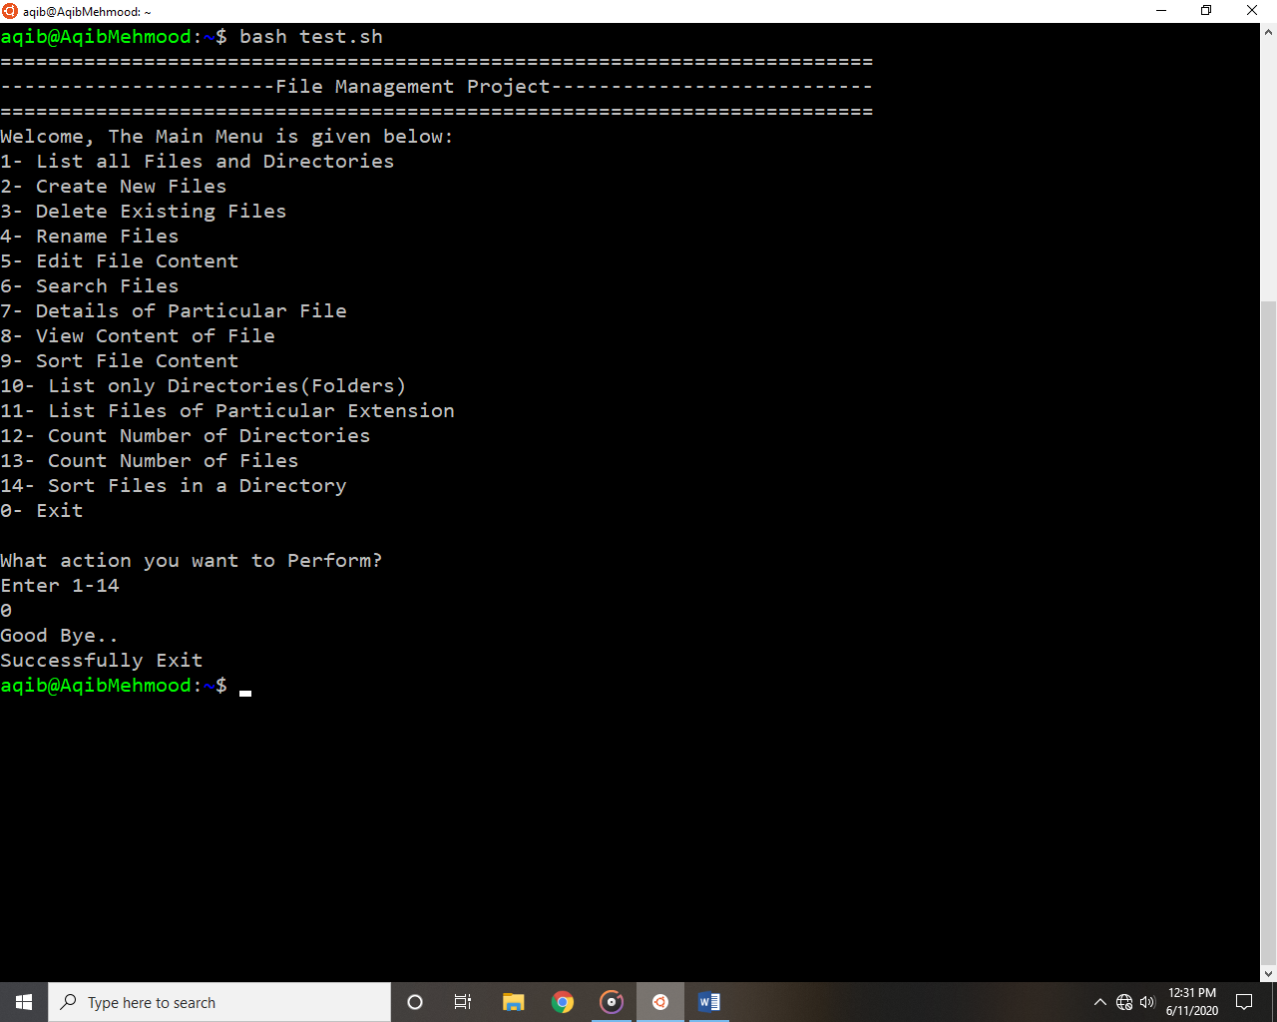

# FUNCTIONALITIES:

The following are some of the functionalities or tasks performed by file management system:

1. List all Files and Directories.
2. Create New Files.
3. Delete Existing Files.
4. Rename an Existing Files.
5. Edit Files Content.
6. Search for Files.
7. Details of Particular File.
8. View Content of File.
9. Sort Files Content.
10. List only Directories.
11. List Files of particular Extension.
12. Count Number of Directories.
13. Sort all Files in a Directories.

The details of all above functionalities is already explained under MECHANISM AND WORKING heading in the form of code of each function.

# REMAINING CODE MODULES, API’S AND PLATFORMS:

No other remaining side work apart from the displayed work above is used in this project. All the functionalities and code of each function is explained above. In this project we use Ubuntu subsystem terminal with C language and bash scripting. So no others platform, API or plug in’s used in this project.

# FUTURE WORK:

This is the most basic version of file management system. So in future we can improve the current version’s functionalities and can add more new functionalities to the system. In the current version of files management system there are 13 different option for a user to manage files and directories. In future we can add more choices for users by understanding the advanced concept about file management in Linux operating system. So this will definitely help users to manage files in a more easy and comfortable manners.

# CONCLUSION:

The project contains some basic functionalities regarding file management like creating new files, delete existing files, rename files, edit files, read or write files and so on. All the functionalities are working on the basis of user’s input from keyboard. There are different basic functions that users can perform on files. These functions are written in C language and bash scripting. All these functionalities are discussed above in the form of code as well as in simple natural language. So everyone having the basic knowledge of computer can use this file management system to perform different functions on files.

# REFERENCES:

* Main Idea from includehelp.com Submitted by Amit Shukla, on August 14, 2017 < <https://www.includehelp.com/operating-systems/file-management-in-operating-system.aspx> >
* How to rename a file answer by Mazhar MIK on askubuntu.com <<https://askubuntu.com/questions/280768/how-to-rename-a-file-in-terminal#:~:text=A%20simple%20way%20to%20rename,from%20one%20name%20to%20another.&text=where%20%E2%80%9Cfile1.>>
* Use of stat command answer by <<https://linuxhint.com/linux_stat_command/>>

~~~~~~**/**THE END**/**~~~~~~